Egger EURODEKOR thin MFC especially for doors
EGGER EURODEKOR Thin MFC is a new product introduction which is available as a 3mm melamine faced board in numerous EGGER decors and surface textures.
For the first time EGGER offers decorative single-sided laminated thin chipboard for the door industry. With this product, the Tyrolean based wood materials manufacturer combines their competence in the manufacture of high quality chipboard with their extensive decor range.

EGGER EURODEKOR Thin MFC is a cost effective product, the surface of which (board type MFC according to EN 14322) is substantially more hardwearing than the films/foils primarily used up until now due to its scratch resistance, resistance to abrasion and resistance towards chemical substances.
“We are convinced that with EGGER EURODEKOR Thin MFC we have developed a product of particular interest for the door industry“, comments EGGER Product Manager Manfred Riepertinger.
The core is made from EGGER thin chipboard produced at the Wörgl (AT) plant, which, thanks to its increased raw density, conforms to the requirements of the RAL quality association for interior doors and meets the special requirements for impact resistance and mechanical stress. The boards, which are manufactured with the calander process, have an especially fine chip structure. They have a low bark content, are light in colour and highly compressed.

Alternative surface layer for eurolight
Apart from the already well-proven 4 mm surface layers, the 3 mm thin chipboard will also be used as surface layers for Eurolight boards (lightweight panels).

Order processing
The processing of orders for the door industry will be performed via the Wörgl plant. Detailed information is available from Jakob Meilinger, Plant Sales Management Wörgl, (Tel. 0043 50 600 13034; jakob.meilinger@egger.com).

Factbox EGGER EURODEKOR thin chipboard decor
- EGGER EURODEKOR Thin MFC  in 3 mm  - Combination of chipboard and decor competence | - Especially suitable for doors  - Economic efficiency  - Hardwearing product characteristics

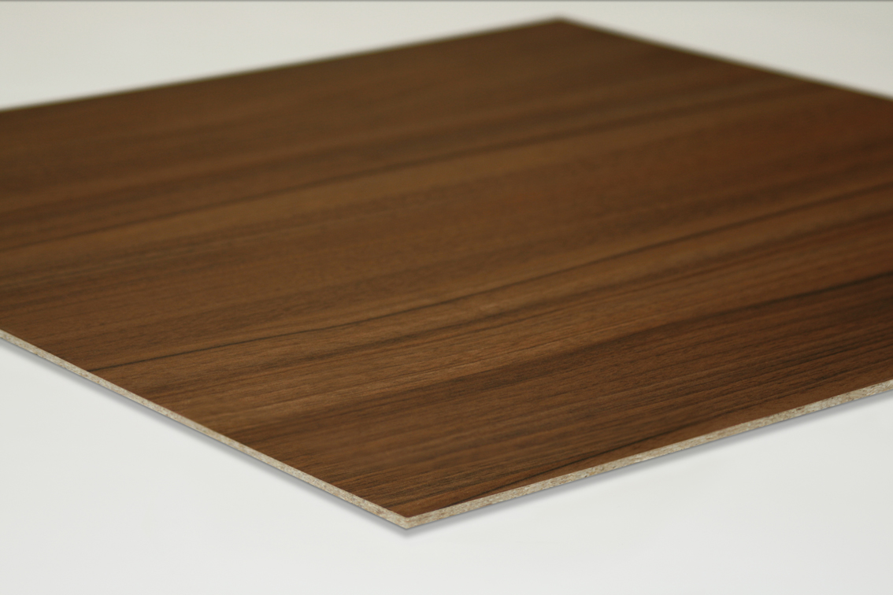
EGGER EURODEKOR Thin MFC in Natural Aida Walnut Aida (H3703) in the surface texture Office (ST15)
For queries:
FRITZ EGGER GmbH & Co.  Wood materials  Christina Werthner  Weiberndorf 20  6380 St. Johann in Tyrol  Austria  T +43 5 0600-10681  F +43 5 0600-90681  christina.werthner@egger.com | PLEON Publico  Dr. Wolfgang Immerschitt  Paracelsusstraße 4  5020 Salzburg  Austria  T +43 662 620 242-0  F +43 662 620 242-20  w.immerschitt@pleon-publico-sbg.at
www.egger.com
PHOTOS EGGER Wood materials, reproduction with naming of copyright holder free of charge

